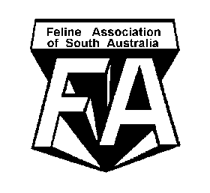

THE FELINE ASSOCIATION OF S.A. INC.

ANNUAL GENERAL MEETING

Monday 1st February 2021

National Council for Women, 95 South Terrace, Adelaide

beginning at 7.00pm

NOMINATION FORM

Nominations and agenda items close 4th January 2021

I……………………………………….........................…..wish to nominate for the following position/s:
(PRINT)

PRESIDENT…………………………………………........ Sign Date…………………...

SECRETARY................................................................ Sign Date...........................

TREASURER............................................................... Sign Date..........................

MANAGEMENT COMMITTEE…………....……………..…. Sign Date……………….....

PROPOSED…….......…..............………....................... Sign Date……............……

SECONDED……………….....……............................... Sign Date…….....…....……

Nominees, proposers and seconders must be current Financial Members.

“Nominees are to be given the opportunity to address the meeting with a short summary of their skills, experience and why they are nominating for the position, and to have such information published in a document published by the association and on the association website at least 21 days prior to the meeting.”
Resumes must be in the hands of the Secretary by 4th January 2021

Nominations and Agenda items close 4th January 2021

All Nominations and Agenda Items must be signed and the hard copy (email accepted)
in the hands of the
Returning Officer: Helen Whittle, 302 Cherry Gardens Road, Cherry Gardens SA 5157 or email
hw@senet.com.au

by the 4th January 2021.
All agenda items must be in writing to the Secretary.

